BVerfG
Infer Justice Referee from Domain of Case
240129
ReadMe

- Other relevant variables

mother file for data preparation: BVerfGDataPreparation240129.R
results pre attempt at inferring referee identity in file bverfg240129intermediate.RData

- Keyword method

actual data preparation in separate files for either senate:
BVerfGDataPreparationRefereeSen1_240129.R
BVerfGDataPreparationRefereeSen1_240129.R
results in separate files
bverfg2.RData (first senate)
bverfg3.RData (second senate)

merge with bverfg240129intermediate.RData
code in file BVerfGDataPreparation240129.R: REFEREE

descriptives
BVerfGReferee240129.R

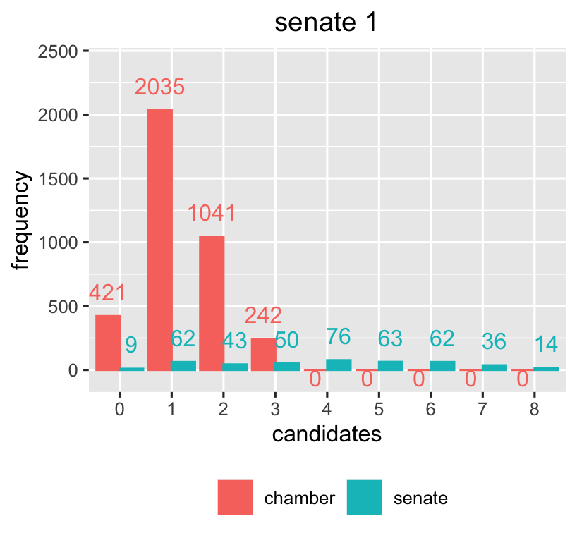

- tie braking with the help of GPT-4

code for preparing the GPT-4 / Python pipeline
and code for analysing the resulting data
BVerfG_GPT240129.R

Python code for running GPT-4 requests
venv
with multiple subfolders


